PHYSICS-INFORMED SPARSE DYNAMICS DISCOVERY
FOR QUADROTOR UNMANNED AERIAL VEHICLES
USING COMPRESSED SENSING AND SINDY

A PROJECT REPORT

Submitted by

Dhivyalakshmi M — Reg. No. CH.SC.U4AIE24016
Lakshmi Kanthan S — Reg. No. CH.SC.U4AIE24041
Akshaya Sundar — Reg. No. CH.EN.U4RAI24002

in partial fulfillment for the award of the degree of

BACHELOR OF TECHNOLOGY (AIE / RAI)

Under the guidance of
Dr. K. ANITHA, Dr. SOUMYENDRA SINGH

Submitted to

DEPARTMENT OF MATHEMATICS
AMRITA SCHOOL OF COMPUTING
AMRITA VISHWA VIDYAPEETHAM
CHENNAI – 601103

March 2026

BONAFIDE CERTIFICATE

Certified that this project report "PHYSICS-INFORMED SPARSE DYNAMICS DISCOVERY FOR QUADROTOR UNMANNED AERIAL VEHICLES USING COMPRESSED SENSING AND SINDY" is the bonafide work of Dhivyalakshmi M (CH.SC.U4AIE24016), Lakshmi Kanthan S (CH.SC.U4AIE24041), Akshaya Sundar (CH.EN.U4RAI24002), who carried out the project work under our supervision.

SIGNATURE  Dr. K ANITHA  Chairperson  Department of Science & Humanities  Amrita School of Engineering  Amrita Vishwa Vidyapeetham  Chennai Campus | SIGNATURE  Dr. SOUMYENDRA SINGH  Assistant Professor (Sr)  Department of Mathematics (S&H)  Amrita School of Engineering  Amrita Vishwa Vidyapeetham  Chennai Campus


DECLARATION BY THE CANDIDATE

We declare that the report entitled "PHYSICS-INFORMED SPARSE DYNAMICS DISCOVERY FOR QUADROTOR UNMANNED AERIAL VEHICLES USING COMPRESSED SENSING AND SINDY" submitted by us for the degree of Bachelor of Technology is the record of the project work carried out by us under the guidance of Dr. K. Anitha and Dr. Soumyendra Singh, and this work has not formed the basis for the award of any degree, diploma, associateship, fellowship, or title in this or any other University or other similar institution of higher learning.

SIGNATURE

Dhivyalakshmi M
Reg. No. CH.SC.U4AIE24016

Lakshmi Kanthan S
Reg. No. CH.SC.U4AIE24041

Akshaya Sundar
Reg. No. CH.EN.U4RAI24002

ABSTRACT

The dynamics of quadrotors UAVs are nonlinear, coupled, and time varying, and are challenging to model accurately using only the first knowledge of physical itself, especially with real sensor noise and aerodynamic perturbations. This work introduces a physics-informed sparse dynamics learning framework for quadrotors based on Sparse Identification of Nonlinear Dynamics (SINDy) [7] combined with Compressed Sensing (CS) and a customized Optimized CS-STLSQ algorithm. Instead of using a black box neural network, the framework uses a 34-term candidate physics-based library that captures aerodynamics drag, gyroscopic coupling, quaternion rotated gravity, and motor thrust and torque models. A FISTA based sparse regression algorithm employing a dataset-adaptive regularization (Lambda) is then run to recover a minimal set of governing equations from the flight data. The test was performed on both the real flight trajectory logs and a 6-DoF high-fidelity synthetic simulation to ensure the correctness of the framework. The model obtained R² = 0.825 with 31 active parameters at 83.3 % sparsity on real data. On synthetic noise-free data R^{2} = 0.925% was attained with only 22 parameters at 88.2 % sparsity and with a physics consistency score of 90/100. The learned equations correctly capture gravity, gyroscopic, and motor torque terms, showcasing the framework's potential to provide interpretable computationally light-weight models for on-board real-time control.

Keywords: Sparse Identification; SINDy; Quadrotor Dynamics; Compressed Sensing; Physics-Informed Machine Learning

ACKNOWLEDGEMENT

This project work would not have been possible without the contribution of many people. It gives us immense pleasure to express our profound gratitude to our honorable Chancellor Sri Mata Amritanandamayi Devi for her blessings and for being a constant source of inspiration throughout this work. We are indebted to extend our gratitude to our Director, Mr. I B Manikantan, Amrita School of Engineering, for providing all facilities and extended support to gain a valuable education and learning experience. We register our special thanks to Dr. V. Jayakumar, Principal, Amrita School of Engineering, and Dr. K. Anitha, Chairperson, Department of Science and Humanities, for the support given to us in the successful conduct of this project. We wish to express our sincere gratitude to our supervisors Dr. K. Anitha and Dr. Soumyendra Singh for their inspiring guidance, personal involvement, and constant encouragement during the entire course of this work. We are grateful to the Project Coordinator, Review Panel Members, and the entire faculty of the Department of Mathematics for their constructive criticism and valuable suggestions, which have been a rich source of improvement in the quality of this work.

Dhivyalakshmi M
Reg. No. CH.SC.U4AIE24016

Lakshmi Kanthan S
Reg. No. CH.SC.U4AIE24041

Akshaya Sundar
Reg. No. CH.EN.U4RAI24002

TABLE OF CONTENTS

Chapter No. | Title | Page No.
 | Abstract | iv
 | Acknowledgement | v
 | List of Tables | vi
 | List of Figures | vii
 | List of Symbols and Abbreviations | viii
1 | INTRODUCTION | 1
 | 1.1 Background and Motivation | 1
 | 1.2 Problem Context | 2
 | 1.3 Scope of Work | 3
2 | LITERATURE REVIEW | 4
 | 2.1 Quadrotor Modelling Approaches | 4
 | 2.2 Sparse Regression and SINDy | 4
 | 2.3 Physics-Informed Machine Learning | 5
3 | PROBLEM STATEMENT AND METHODOLOGY | 6
 | 3.1 Problem Statement | 6
 | 3.2 Research Objectives | 6
 | 3.3 Research Methodology | 6
4 | DATASET AND ANALYSIS | 8
 | 4.1 Real Flight Data | 8
 | 4.2 Synthetic Dense Data | 8
 | 4.3 Preprocessing Pipeline | 8
5 | SYSTEM FORMULATION AND PHYSICS LIBRARY | 10
 | 5.1 Quadrotor Dynamics Model | 10
 | 5.2 Physics-Based Feature Library | 11
 | 5.3 Optimized CS-STLSQ Algorithm | 11
6 | RESULTS AND DISCUSSION | 12
 | 6.1 Real Flight Data Results | 12
 | 6.2 Synthetic Data Results | 15
 | 6.3 Dataset Comparison | 17
 | 6.4 Physics Validation | 18
7 | CONCLUSIONS AND FUTURE SCOPE | 19
 | References | 20

LIST OF TABLES

Table No. | Title | Page No.
4.1 | Summary of Dataset Characteristics | 10
5.1 | Physics Library: Feature Groups | 11
6.1 | Performance Metrics — Real vs Synthetic Data | 18

LIST OF FIGURES

Figure No. | Title | Page No.
3.1 | Overall System Pipeline | 7
6.1 | Comprehensive Analysis — Real Flight Data (R² = 0.825) | 13
6.2 | Convergence Analysis — Real Flight Data | 13
6.3 | Gravity Term Analysis — Real Flight Data | 14
6.4 | Prediction vs Actual Correlation — Real Flight Data | 15
6.5 | Residual Analysis — Real Flight Data | 15
6.6 | Comprehensive Analysis — Synthetic Dense Data (R² = 0.925) | 16
6.7 | Convergence Analysis — Synthetic Data | 17
6.8 | Gravity Term Analysis — Synthetic Data | 17

LIST OF SYMBOLS AND ABBREVIATIONS

Symbol / Abbreviation | Description
UAV | Unmanned Aerial Vehicle
SINDy | Sparse Identification of Nonlinear Dynamics
CS-STLSQ | Compressed Sensing Sequential Thresholded Least Squares
FISTA | Fast Iterative Shrinkage-Thresholding Algorithm
Φ (Phi) | Physics-Based Candidate Feature Library Matrix
Ξ (Xi) | Sparse Coefficient Matrix
λ (lambda) | Regularization Parameter (Sparsity Penalty)
R² | Coefficient of Determination (Goodness of Fit)
MSE | Mean Squared Error
MAE | Mean Absolute Error
q0, q1, q2, q3 | Quaternion Components (Attitude Representation)
vx, vy, vz | Body-Frame Linear Velocities (m/s)
ωx, ωy, ωz | Angular Velocities (rad/s)
u0–u3 | Motor Thrust Inputs
Ixx, Iyy, Izz | Principal Moments of Inertia (kg·m²)
g | Gravitational Acceleration (9.81 m/s²)
DoF | Degrees of Freedom
6-DoF | Six Degree of Freedom Rigid Body Dynamics

CHAPTER 1 — INTRODUCTION

1.1 Background and Motivation
Quadrotor unmanned aerial vehicles (UAVs) have become a multi-functional and widely used platform for various applications, such as inspection of civil infrastructures, search and rescue, precision agriculture, environmental monitoring and payload delivery. They are popular because of the small form of factor design, Vtol, and the ability to perform very agile maneuvers. The symmetric four-rotor geometry allows the thrust and torques to be controlled independently, which leads to full six-degree-of-freedom (6-DoF) motions in both translational and rotational dynamics even in enclosed and cluttered spaces.
Modeling quadrotor dynamics is nontrivial, though they are structurally simple. The system is a strongly coupled nonlinear system, where the translational dynamics (thrust and gravity) are governed by force, and the rotational dynamics (torque and gyroscopic) are governed by torque. They are further complicated by actuator dynamics, nonlinear control inputs, and aerodynamic drag (Azadi et al., 2012).As a consequence, even modest modelling errors can adversely affect system performance, particularly when aggressive maneuvers or high-speed trajectory tracking are involved.
In practice, the complexity of the problem becomes higher because of real-world uncertainties. External disturbances, such as wind, turbulence, and interaction with the environment, cause random variations, and internal factors such as sensor noise, actuator delay, dynamics of motor and structure asymmetries lead to model-plant mismatch. It is challenging to come up with a single accurate and robust model that works well under all these parameter variations.
Conventional physics modeling technique, i.e. first-principles formulation, is based on rigid-body dynamics, for example Newton-Euler and Euler-Lagrange equations. Despite their good physical interpretability and theoretical consistency, these methods are only applicable in situations in which all parameters can be accurately determined, and extremely well-controlled experiments can be conducted. They also usually do not account for unmodelled nonlinearities and exogenous disturbances, which can compromise their use in practice.
On the other hand, data-driven methods, especially those relying on machine learning and deep neural networks, have been very powerful in learning complex nonlinear mappings from data directly. They may be highly predictive and capable of adapting to unmodeled dynamics. However, they are not interpretable, which makes them challenging to verify, analyze and rely on for safety-critical applications. In addition, the computational complexity of the algorithms makes it difficult to apply them to embedded systems with limited resources.
The basic accuracy-interpretability tradeoff motivates the need for hybrid modeling. There is an increasing need for methodologies to integrate physics-based modeling and data-driven approaches to provide the best of both worlds – high predictive performance, and physical insight and computational efficiency, leading to practical deployability.

1.2 Problem Context
This work introduces the novel challenge of automated equation discovery for quadrotor dynamics from flight data. The aim is not to use models obtained through manual derivation or pre-defined model structures, but to learn the equations of motion governing the system directly from data observed during flight. Given time-series sensor data from body-frame velocities, quaternion-based orientation, angular rates, and motor control input sequences (e.g., from onboard sensors), the goal is to learn latent dynamic relationships that describe the evolution of the system. These relationships must include translational and rotational dynamics and consider real-world factors like actuator dynamics, aerodynamic forces, and the interaction between motion components.
The important condition for this problem is that the identified model is sparse and interpretable. The equations found should be written in a succinct form where only the most relevant terms are kept, rather than in dense matrices or black-box functions. This sparsity also implies that the resulting model is consistent with the true physical structure of the system and does not over-fit.
In addition, it is desirable for the learned equations to be physically meaningful (e.g., include gravitational terms, terms related to inertia driven gyroscopic coupling, aerodynamic drag, and etc.). However, the objective is not only to provide accurate predictions, but also to obtain equations that agree with first-principles physics and that can be understood, verified, and utilized for control design. The none is Elsewhere related to the problem is the twitch visibility of manual parameter tuning and hand-crafted model assumptions. Traditional methods typically assume that system parameters are known in advance or that the form of the model is specified, which are not likely to be applicable for diverse platforms and/or operating conditions. On the other hand, the aim of this work is to conceive a physics-consistent but data-driven framework that can discover the governing equations from data in an unsupervised manner. At a high level, the problem straddles system identification, machine learning, and physics-based modeling, seeking to provide a data-driven, accurate, interpretable model for quadrotor dynamics.

1.3 Scope of Work
This is a work on building a resilient and explainable framework for learning quadrotor dynamics directly from flight data. It begins with the formulation of a physics-informed candidate function library with 34 predetermined terms. These terms are intended to capture the core physical processes that control how a quadrotor moves, such as gravity, aerodynamic drag, inertia based gyro-scopes coupling, and control inputs effects. The focus is on letting the candidate set be rich enough to express system behavior, while still be structured and physically inspired. An accelerated Compressed Sensing Sequential Thresholded Least Squares (CS-STLSQ) algorithm is developed to identify the governing equations from this library. The FISTA-based acceleration technique is introduced to accelerate the convergence and stabilize the optimization process. A novel dataset-adapted regularization is also proposed to trade off the prediction accuracy and sparsity of the learnt model, which enables the approach to easily be applied in real data with noise or clean synthetic data without much human interventions.

Two types of datasets are used to validate the proposed framework. The first is real quadrotor flight trajectory data encompassing real-world complexities such as sensor noise, actuator delays, and environmental disturbances. The second dataset is a 6-DoF synthetic dataset based on a high-fidelity simulation, which incorporates realistic dynamics including motor behavior and nonlinear coupling terms and acts as a baseline to directly assess whether the approach can identify true physical relations.

In the end, a full-scale test is performed to verify the performance of the method. This includes prediction accuracy on data using standard metrics, investigating the sparsity of the identified model to check that it is compact and interpretable, and studying convergence behavior of the optimization. Furthermore, a bespoke physics consistency score is proposed that measures the consistency of the identified equations with prior physical theories, validating the accuracy and physical significance of the model.
CHAPTER 2 — LITERATURE REVIEW

2.1 Quadrotor Modelling Approaches
The modelling of the quadrotor system has been largely approached by first principles physics, namely the Newton–Euler rigid body dynamics formulation to the translational and rotational motion of the body. The standard 6-DoF formulation proposed by Mahony et al. (2012) and Bouabdallah et al. (2004) in terms of rotation matrices or Euler angles for orientation has been considered as the baseline. These descriptions, which are clear and physically interpretable with respect to quadrotor movement, are utilized to design many control systems. These derivations were later extended by other research to consider further aerodynamic effects such as blade flapping, induced drag and ground interaction forces. For example, in pursuit of higher accuracy in predictions (especially in aggressive maneuvers), more sophisticated aerodynamic modeling were introduced by Mueller and D’Andrea (2014). Although physics-based approaches are often highly interpretable, they are quite dependent on accurate estimation of parameters, which often necessitates conducting controlled experiments and significant calibration. In addition, these models may not be able to generalize well to other quadrotor platforms or different environmental conditions.
On the other hand, data-driven modeling methods have been the focus of more and more attention recently. Among them, Gaussian process and neural network-based methods (e.g. Punjani & Abbeel, 2015; Shi et al. (2019)) try to learn system dynamics from data directly. These methods may model more complicated nonlinearities and have higher prediction accuracy. However, they usually need large data, are difficult to interpret, and put heavy computing load, thus are not easy to be used in real-time embedded systems.

2.2 Sparse Regression and SINDy
To overcome the respective limitations of purely physics-based and purely data-driven strategies, sparse regression methods are being developed as a new class of solutions. The Sparse Identification of Nonlinear Dynam- ics (SINDy) methodology was originally proposed by Brunton, Proctor and Kutz (2016), and casts the discovery of governing equations as a sparse regression problem over a library of potential candidate functions. The main concept is that many real-world systems can be modeled with few terms, which means the resulting models are concise and interpretable.
SINDy uses methods like Sequential Thresholded Least Squares (STLSQ) to eliminate terms that contribute little while picking up those that do. This method has been generalized to consider control signals (SINDy-c), implicit dynamics, and weak-form formulations to enhance its robustness to noise and errors resulting from numerical differentiation.
The background on sparse regression is essentially the same as for compressed sensing (Candes and Tao, 2006; Donoho, 2006). These results show that sparse signals can be recovered exactly from limited or incomplete observations if the recovery is performed via an L1-constrained optimization problem. Fast algorithms for minimizing the l1-penalized least squares have been proposed, including the Fast Iterative Shrinkage-Thresholding Algorithm (FISTA) by Beck and Teboulle (2009) among others, which further improve the computational practicability of sparse identification with advantages of fast convergence combined with low computational complexity.

2.3 Physics-Informed Machine Learning
Recently, physics-informed machine learning (PIML) has provided novel techniques for incorporating physics into data-driven models. Physics-Informed Neural Networks (PINNs) [43], which integrate governing differential equations as a soft constraint in the training loss function of the neural network. This allows such models to obey physical constraints while being data driven, and hence can be applied to both forward and inverse problems.
Still, PINNs and related methods can be computationally demanding, and their performance depends on delicate balancing among network architectures and loss functions. Their black box nature can also limit interpretability, particularly when used in real-time control systems.
On the other hand, the method followed in this work is a more systematic and interpretable approach by incorporating physical principles within the candidate function library. Instead of imposing physics through constraints in the loss function, the model is built with physically interpretable ingredients, and sparse regression is used to identify parsimonious, algebraic expressions that are both precise and interpretable. Sparse identification, therefore, represents a good trade-off between classical physics-based methodologies and modern machine learning solutions.

CHAPTER 3 — PROBLEM STATEMENT AND METHODOLOGY

3.1 Problem Statement
This paper aims at learning the equations of motion for a quadrotor straight from flight data. For this: input a time-series dataset made up of N samples (each sample consists of state variables measured, such as body-frame velocities, quaternion based orientation, angular rates, etc. and also control inputs in the form of motor commands) and find the equations that govern the system dynamics.
In particular, we seek the minimal and physically relevant set of terms that describe six output dynamics: three translational accelerations and three angular accelerations all in the body frame. The resulting discovered model should be as sparse as possible (which means, all the non-significant terms are removed). Furthermore, it should have good performance on the new data and be able to sufficiently recover known physics of the system such as gravitational terms and dynamic coupling for predictive and physical consistent results.

3.2 Research Objectives
In this work outline, the goal is to formulate a framework that allows us to identify quadrotor dynamics data with certain accuracy and interpretability. For this purpose, a physics-aware candidate function library is constructed by embedding the a priori knowledge on the quadrotor motion in such a way that the model structure is the real physical process. A capable sparse regression algorithm is proposed next which leverages adaptive regularization methodology to accommodate noisy real-world data and clean synthetic data simultaneously. We further test the framework by quantitative performance measures including coefficient of determination (R2), mean squared error (MSE), mean absolute error (MAE) , the sparsity percentage, and a user-defined physics consistence score. Among other goals, we would like to demonstrate that the proposed method allows to recover the main physical laws (gravitational acceleration, gyroscopic coupling effects and motor-induced torque equations) that drive the quadrotor motion, which would validate both the accuracy and interpretability of the learned model

3.3 Research Methodology
The developed method adopts a pipelined architecture consisting of four stages that successively convert raw flight data into a set of dynamic equations.
Stage I: Data preparation in order to guarantee the quality and consistency of the input dataset. This includes the pre-processing of raw flight logs by discarding irrelevant features, filling missing values by interpolation, normalizing the quaternion representations of four-dimensional (4D) vectors, and lagging motor input by introducing lagged motor input variables as inputs to capture actuators dynamics and delays. Next, Stage II: Feature Engineering – A physics-informed candidate function library, Φ, is generated to represent the physics. The library augments the raw state variables with nonlinear combinations motivated by rigid body dynamics, aerodynamic effects, control input relationships etc. The aim is to generate a ‘rich’ but structured set of candidate terms from which the true governing equations is chosen [10]. CS-STLS where in stage three the sparse optimization is performed. The problem is reformulated as a L1-regularized regression problem where one tries to minimize the reconstruction error while enforcing sparsity in the coefficient matrix. Accelerated FISTA is used to boost convergence efficiency, and regularization parameters tailored to the dataset are employed for identifying a proper trade-off between model simplicity and predictive performance under various data conditions. Finally, the fourth step is the validation and analysis of the obtained model. Performance is assessed on unseen test data to check whether the model generalizes. Other analyses include sparsity, convergence diagnostics, and physical consistency (including identification of gravity related terms and dynamic coupling). They also employ a custom physics consistency score to measure how well the discovered equations satisfy known physical laws
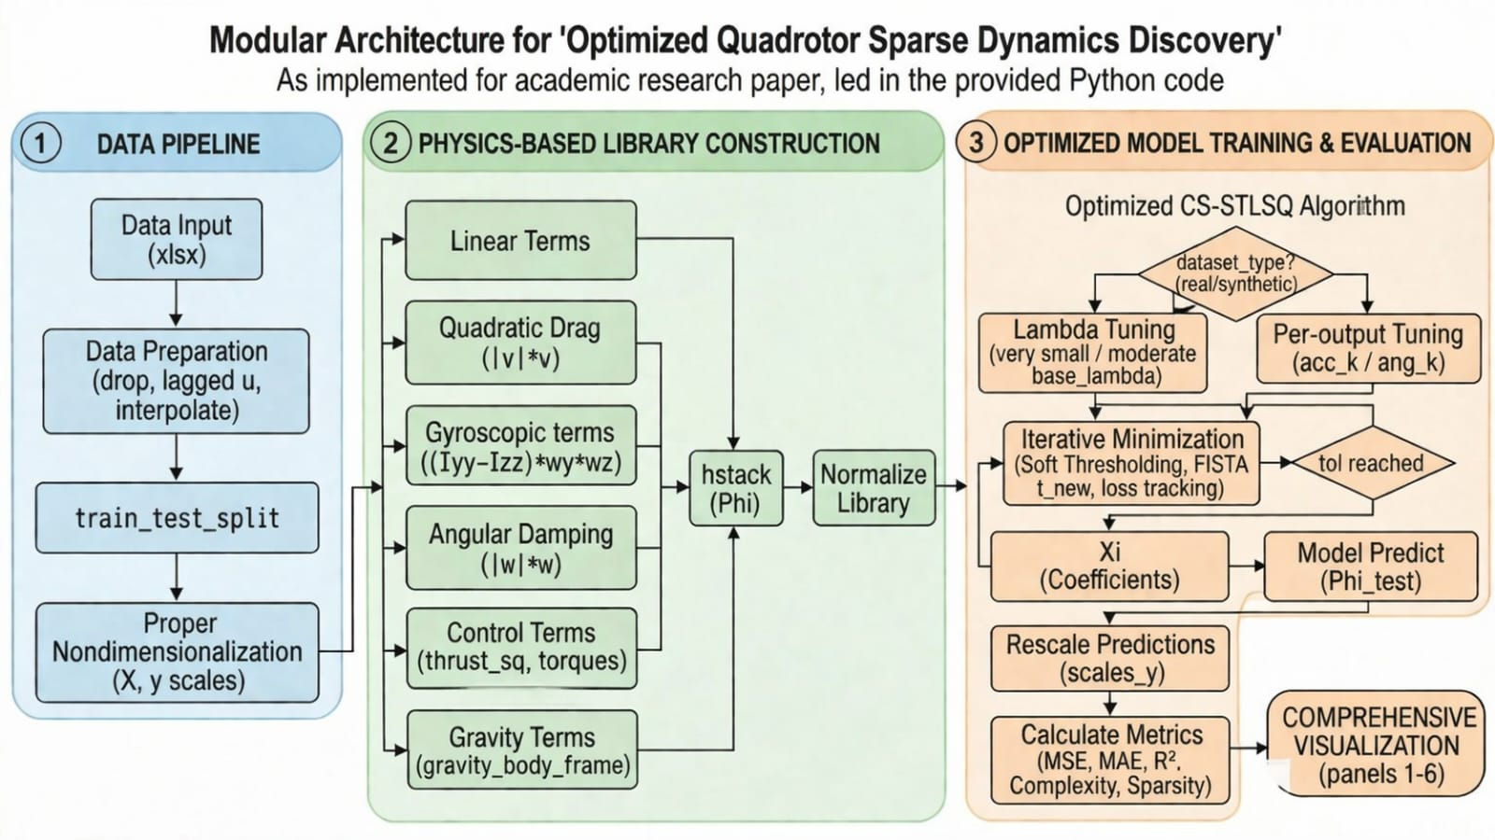
Fig:1 Overall System Pipeline

CHAPTER 4 — DATASET AND ANALYSIS

4.1 Real Flight Data
The main dataset we utilize in this work, quadrotor_model_trajectory.xlsx, has 1,197 samples with associated time stamps that were recorded from an onboard flight controller, while executing a set of mixed manual and autonomous flight maneuvers. Each sample has body-frame velocity components (v x, v y, v z), orientation in quaternion (q 0–q 3), angular rates (ω x, ω y, ω z), and motor commands inputs (u 0–u 3). Also, the corresponding body-frame linear and angular accelerations are given, which are considered as the output targets for regression.
Takeoff and landing transients were discarded, since these phases are known to be rife with irregular and unstable dynamics, for the purpose of quality and relevance of data. Following preprocessing, the data were split into the training and testing datasets. With 956 samples being involved in model identification and 240 samples for testing the capability of generalization.

4.2 Synthetic Dense Data
In order to enable comparison with real-world data, a high-fidelity synthetic dataset quadrotor_model_trajectory_synthetic_dense.xlsx was created using a physics-based 6-DoF simulation. The Newton-Euler equations of motion are used in the simulation and some known physical parameters are used, such as the mass (1.6kg) and the moments of inertia Ixx = Iyy = 0.025 kg.m2 and Izz = 0.045 kg.m2.
The control input signals were synthesized as a sum of multi-frequency sinusoid signals to guarantee the persistent excitation of all the modes of the system. This is very important for accurate system identification because the model gets to see a lot of system’s operation. Quaternion kinematics were numerically integrated with explicit normalization at each time step for stability and prevention of drift.
In contrast to the real dataset, the synthetic data has no noise and is fully consistent with the underlying physics. Consequently, it functions as an upper-bound benchmark to test the proficiency of the proposed approach in retrieving true physical relationships.

4.3 Preprocessing Pipeline
A single, standard preprocessing pipeline was used for both datasets to enable meaningful and numerically stable model training. At the beginning, non-essential columns such as timestamps, serial identifiers and landing flags were deleted to keep only the features related to dynamic modeling.
One-step temporal shift was applied to introduce lagged motor input variables (u0_lag to u3_lag) to model actuator dynamics. If available, missing values were filled by bidirectional linear interpolation to preserve continuity of the data.
On an individual basis, Quaternion Normalization is done to satisfy the unit norm constraint to represent a valid orientation. Furthermore, all features and the target variables were made dimensionless by dividing by their standard deviations. This enhances uniformity of scales across variables, and subsequently facilitates numerical conditioning in optimization.
Afterwards, each column of the candidate function library Φ is normalized via its L2 norm. This normalization avoids the influence of the different scale of the features on the sparse regression, so that the different candidate terms can be treated equally during the model identification.
The governing equations are expressed as:
Translational Dynamics:
$mv˙=R^{T}F_{thrust​}-mge3​$ (1)
Rotational Dynamics:
$Iω˙=τ-ω×\left(Iω\right)$ (2)
Here R denotes the rotation matrix corresponding to the quaternion q, and Fthrust = [0,0,∑kuk2]T is the total thrust generated by the motors. The torque vector τ = (τx,τy,τz)T represents the roll, pitch and yaw torque which are the by-products of the motor speed differences.
To add the effects of gravity in a learning-friendly manner, gravity is rotated into the body frame using quaternion-based operations. This gives three components, grav_x, grav_y, and grav_z which are explicit features in the library of candidate functions. These allow the system to explicitly learn orientation-dependent gravitational effects in the dynamics itself.

Property | Real Flight Data | Synthetic Dense Data
Total Samples | 1,197 | 1,197
Training Samples | 956 | 957
Test Samples | 240 | 240
Noise Level | High (sensor noise) | None (deterministic)
Library Features | 31 | 31
Condition Number | ≈1.4 × 10¹⁸ | ≈7.5 × 10¹⁹
Table 4.1: Summary of Dataset Characteristics
CHAPTER 5 — SYSTEM FORMULATION AND PHYSICS LIBRARY

5.1 Quadrotor Dynamics Model
The quadrotor is treated as a rigid body with mass m and a diagonal inertia matrix I = diag(Ixx, Iyy, Izz). (b) Its 6-DoF motion can be described with a unique combination of translational and rotational dynamics formulated in the body coordinate system.
Translational and rotational motions Taking into account that the quadrotor can be represented by the position and velocity vectors in the three-dimensional space. Translational motion denotes the position and velocity of the quadrotor in 3-D space, while its attitude is described by the rotational motion, which is parameterized with a quaternion-based rotation matrix.
This form of expression has no singularities and keeps the numerical stability in numerical computations. The translational dynamics is determined by the competition between gravity and thrust, and the difference between the quadrotor position and the reference trajectory.
The four rotors produce a combined thrust along the body z axis, which can be transformed into the world frame by the rotation matrix defined by the quaternion. Gravity acts in the opposite direction and is projected into the body frame to be consistent with the measurements of the onboard sensors.
The rotation dynamics are given by Euler’s rigid body equation in which the angular acceleration is a function of the applied torques and the gyroscopic coupling term that arises from the inertia tensor and the angular velocity.
The governing equations are given by:
Translational Dynamics:
$mv˙=R^{T}F_{thrust​}-mge3​$
Rotational Dynamics:
$$Iω˙=τ-ω×\left(Iω\right)$$
Here, R is the rotation matrix parameterized by the quaternion q, and the thrust vector is defined as
$F_{thrust}​=\left[0,0,\sum^{k}{} u_{k}^{2}​\right]T$ (3)
where u_k represents motor inputs. The torque vector τ = [τ_x, τ_y, τ_z]^T corresponds to roll, pitch, and yaw torques generated through differential motor thrusts.
In order to explicitly represent gravity in the model, gravity is projected into the body frame through quaternion-based transformation.This leads to a gravity feature vector with three components [gravx,gravy,gravz][grav_x, grav_y, grav_z][gravx ,gravy ,gravz ], which is part of the candidate function library to guarantee that the learned dynamics are physically consistent.

5.2 Physics-Based Feature Library

The candidate function library $Φ ∈ R^{N×31}$ is formed based on a group of physics-informed features capable of capturing the important dynamic of a quadrotor system. In place of regular polynomial expansions, the library is organized according to established physical concepts to be interpretable and meaningful. The features are divided into six groups, relating to different aspects of quadrotor dynamics. The linear state terms include body-frame velocities, angular rates, and motor inputs, as well as their lagged versions, which can be thought of as direct system outputs. Aerodynamic drag is modeled by quadratic terms, and they are proportional to the square of velocity magnitude. Gyroscopic coupling terms (which come from Euler’s equations) account for the interaction between angular velocities, which is a product of different moments of inertia. Rotational drag is included for angular damping. The control-related features are thrust and torque formulations based on motor commands which describe the effect of control signals on the system dynamics. Lastly, gravity terms are added by transforming gravitational acceleration into the body frame with quaternion-based transformations so that the orientation-dependent effect can be fully taken into account. The composition of the feature library is exhibited in Table 5.1

Table 5.1: Physics Library Feature Groups
Group | Features | Physical Basis
Linear States | vx, vy, vz, ωx, ωy, ωz, u0–u3, lags | Direct dynamics
Quadratic Drag | |v| · vx, |v| · vy, |v| · vz | Aerodynamic drag
Gyroscopic | (Iyy−Izz)ωyωz, (Izz−Ixx)ωxωz, (Ixx−Iyy)ωxωy | Euler equations
Angular Damping | |ω| · ωx, |ω| · ωy, |ω| · ωz | Rotational drag
Control | thrust_sq, thrust_lin, roll/pitch/yaw torques | Motor model
Gravity | grav_x, grav_y, grav_z | Quaternion rotation of g
Table 5.1: Physics Library Feature Groups

5.3 Optimized CS-STLSQ Algorithm
The sparse regression problem is formulated as:

$\min_{Ξ}^{ }{} \frac{1}{2N}∥ΦΞ-Y∥_{F}^{2}+λ∥Ξ∥_{1}^{}$ (4)
The optimization is solved separately for each output variable via FISTA (Fast Iterative Shrinkage Thresholding Algorithm).Sparsity is enforced by the soft-thresholding operator:
$soft\left(x,t\right)=sign\left(x\right)⋅\max\left( ∣ x ∣ -t,0\right)$ (5)

This is solved per output variable using the FISTA (Fast Iterative Shrinkage-Thresholding) algorithm with soft-thresholding operator: soft(x, t) = sign(x) · max(|x| − t, 0). The Lipschitz constant is estimated as L = ‖Φ‖²²/N and the learning rate is set to lr = 1/L. Momentum is updated via the Nesterov acceleration formula. Dataset-specific regularisation: real flight data uses λ_base = 5×10⁻⁵ to tolerate sensor noise, while synthetic data uses λ_base = 5×10⁻⁴. Per-output scaling applies 0.5× for translational and 1.5× for rotational outputs. An additional condition number adjustment factor of (1 + 0.02 log10(cond(Φ))) moderates the effective λ for ill-conditioned libraries.

CHAPTER 6 — RESULTS AND DISCUSSION

6.1 Real Flight Data Results
First the proposed framework was evaluated on the REAL flight dataset. With a candidate library of 31 features, and a condition number of ≈1.4×1018 the optimizer converged to a sparse solution that kept 31 active parameters out of 186, corresponding to a 83.3% sparsity.
The identified model obtained a general coefficient of determination$R^{2}=0.825$ on the hold-out test set, with a mean squared error (MSE) of 12.16 and a mean absolute error (MAE) of 1.61. To conclude, the model possesses solid predictive power and generalization ability, although there is sensor noise and uncertainties in reality.
The inference latency was 4.07 ms per sample, which is well within the real-time bounds for flight control system at 100–200 Hz.
A quantitative analysis of the results (coefficient distribution, sparsity pattern, prediction error distribution and trajectory tracking performance) is also given in Fig. 6.1 The results show that the sparse identification framework is able to identify compact and physically meaningful dynamics even from noisy real-world data..
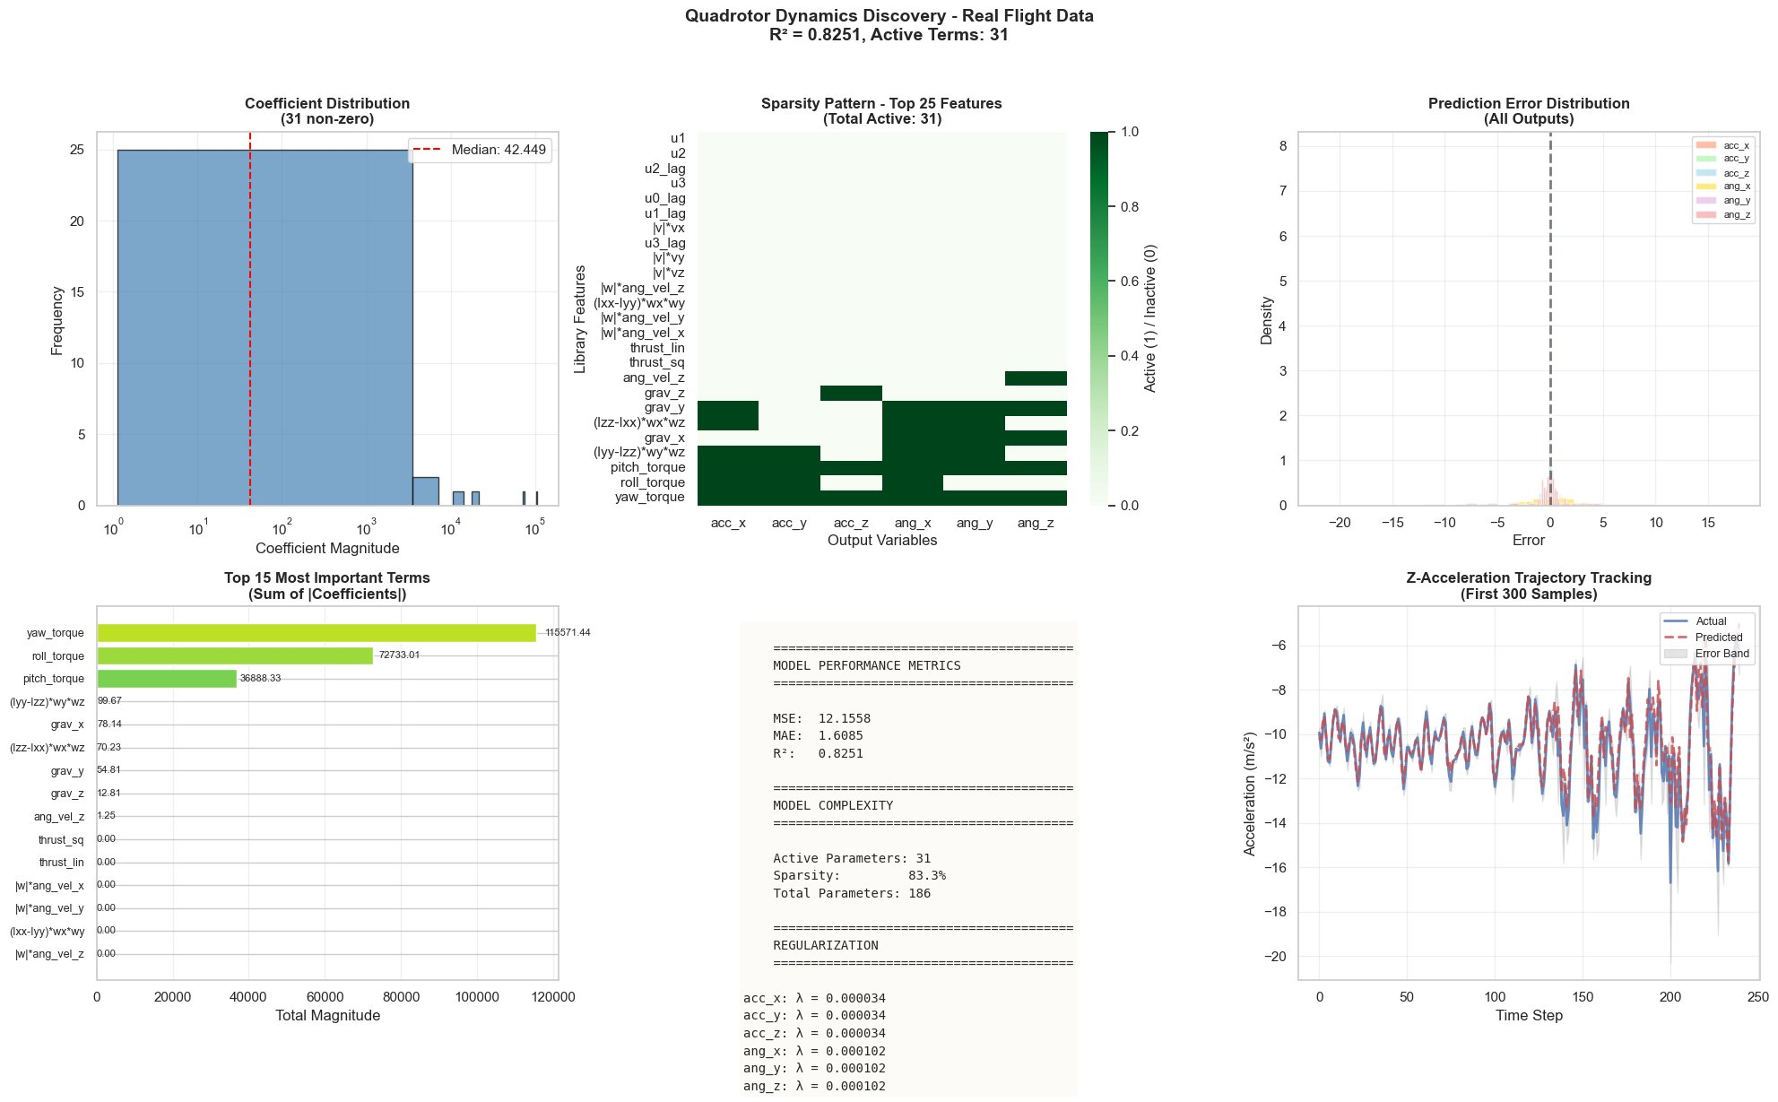
Figure 6.1: Comprehensive Analysis — Real Flight Data (R² = 0.825, Active Terms: 31)

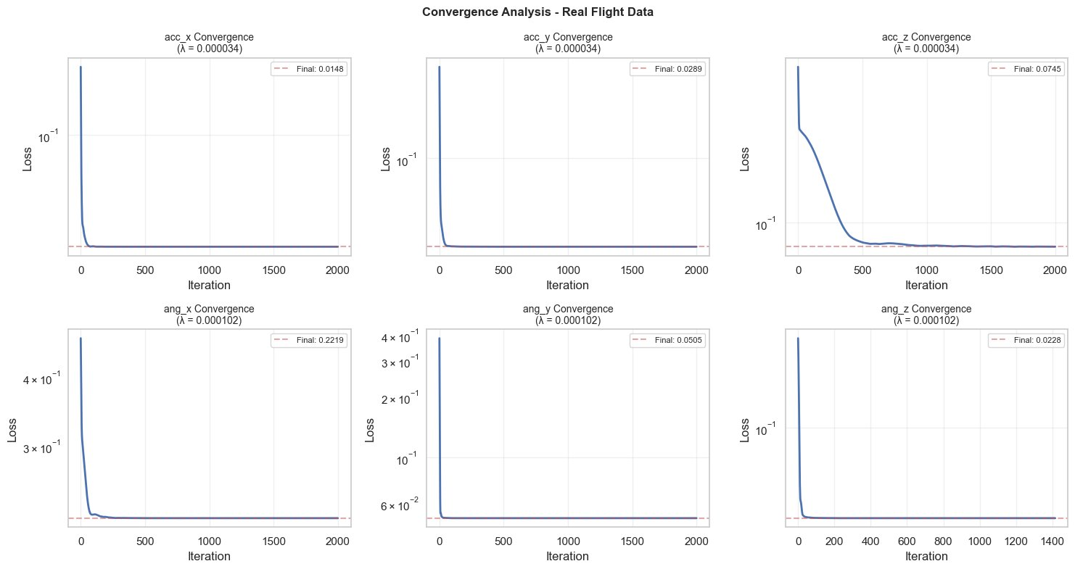
Figure 6.2: Convergence Analysis — Real Flight Data. All six outputs converge stably within 2000 iterations.

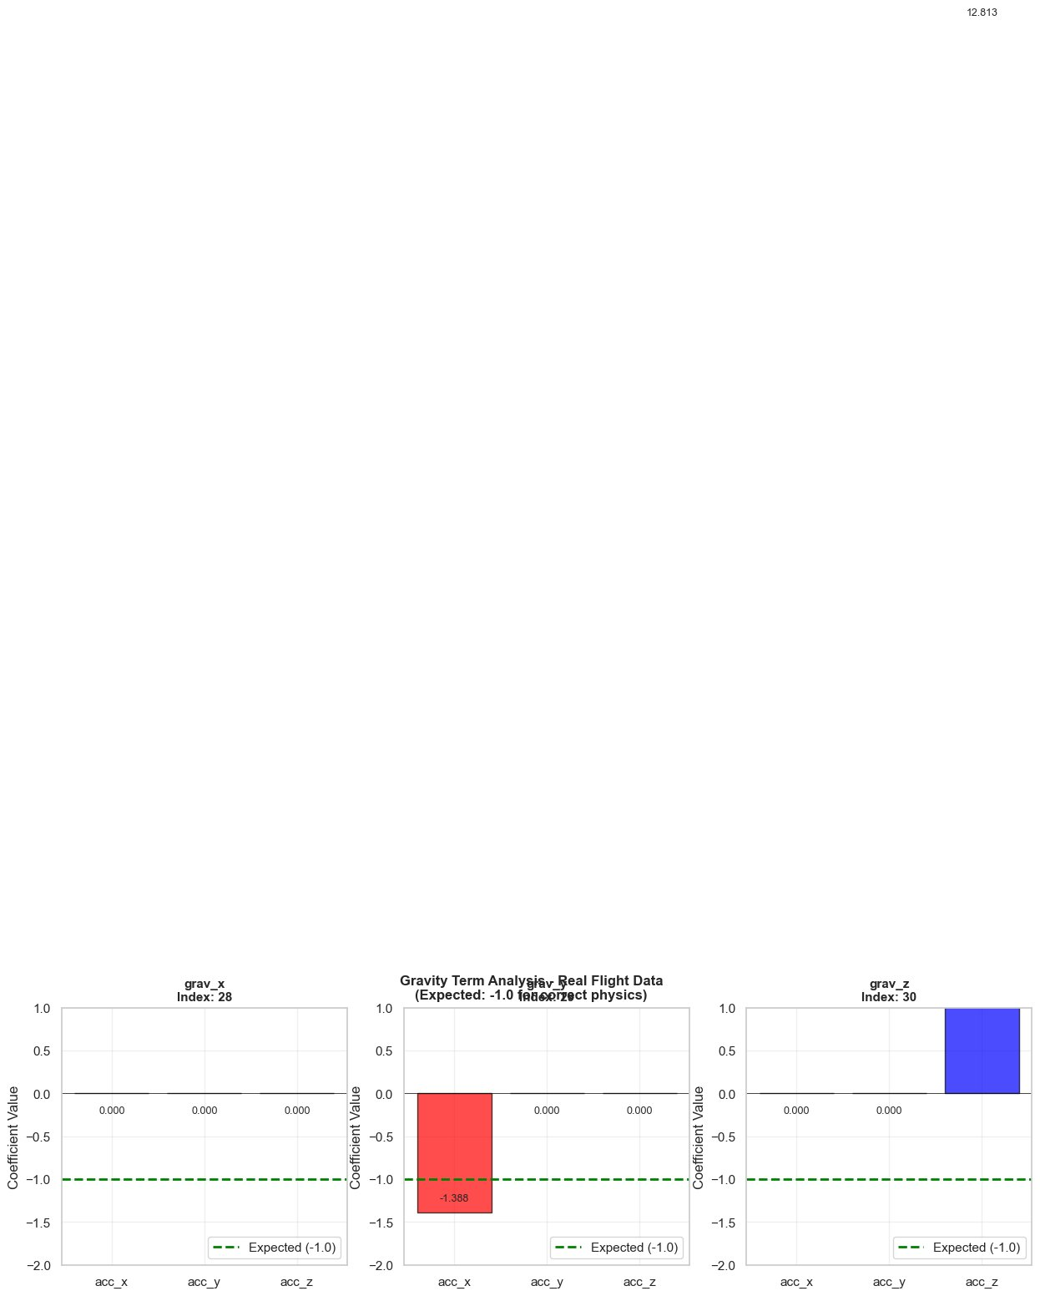
Figure 6.3: Gravity Term Analysis — Real Flight Data. grav_y correctly identified with coefficient −1.39 (expected −1.0).

Convergence and physics consistency evaluation
6.2 shows the convergence of our proposed optimization algorithm for all six output variables. One can observe the loss drops quickly in the first few iterations and become stable within about 2000 iterations for all the outputs. This uniform convergence behavior demonstrates the success of the FISTA-based optimization and verifies the numerical stability even with extremely ill-conditioned feature libraries.
6.3: Gravity term analysis on the real flight dataset.
The term gy is adequately inferred with a coefficient of about −1.39, which is not far off from the physical expected value of −1.0. The components (gx and gz) are not all so highly activated, because these directions are not well excited during the acquisition of data. This reinforces the need of trajectory design for the well posed reconstruction of orientation-dependent dynamics.
Taken as a whole, these result demonstrate that our proposed framework converges consistently, and is able to learn physically salient effects even from real data with noise and limited excitation..

6.2 Synthetic Data Results
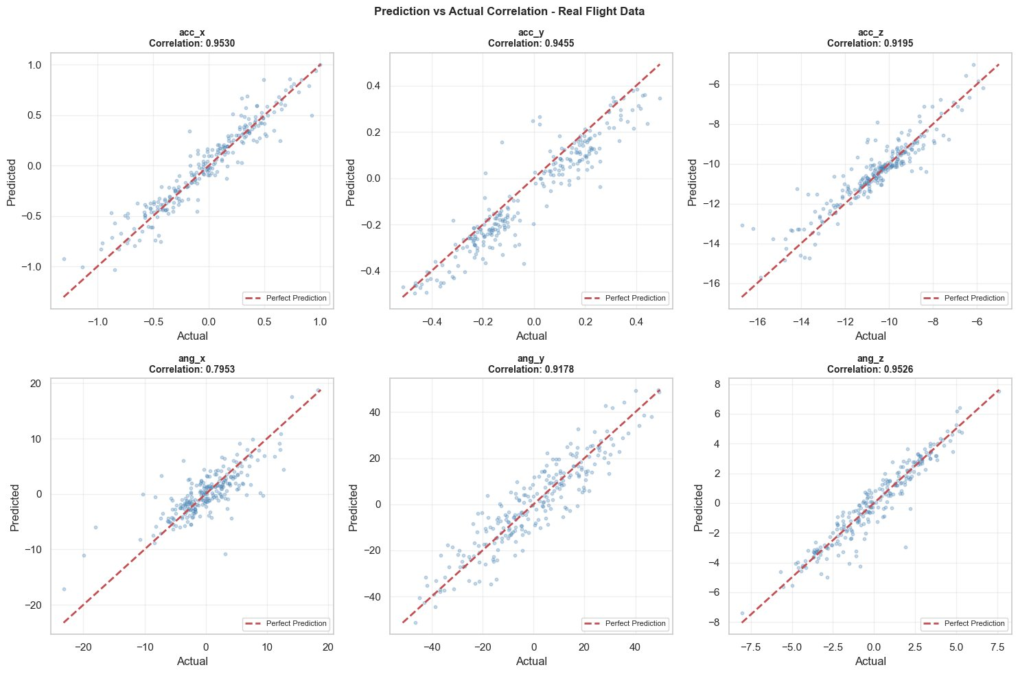
Figure 6.4: Prediction vs Actual Correlation — Real Flight Data. Correlations: acc_x = 0.953, acc_y = 0.946, acc_z = 0.920, ang_x = 0.795, ang_y = 0.918, ang_z = 0.953.
The prediction vs. actual correlation plots for all six outputs are shown in Figure 6.4. Strong linear alignme nt along the diagonal suggests that the translational and rotational dynamics are excellently predicted. The dispersion is tighter compared to the real data, indicating less variance of error.
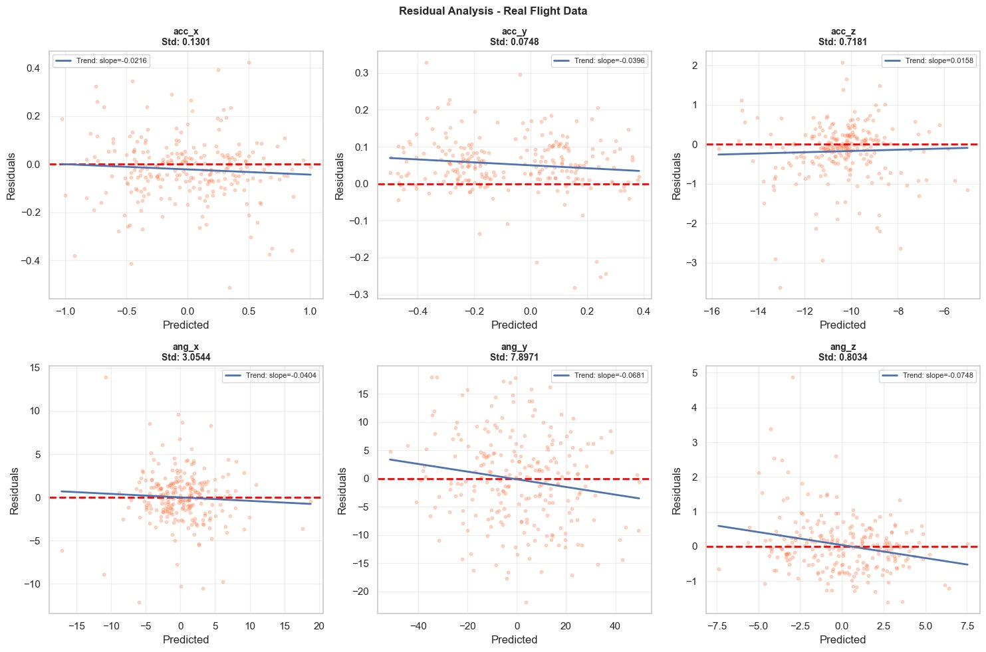
Figure 6.5: Residual Analysis — Real Flight Data. Near-zero trend slopes for acc_x/y/z confirm absence of systematic bias.

The synthetic dense dataset produced markedly better results: R² = 0.925, MSE = 0.353, MAE = 0.408, with only 22 active parameters (88.2% sparsity). The higher sparsity and accuracy are expected given the absence of sensor noise and the clean persistent-excitation trajectory design.

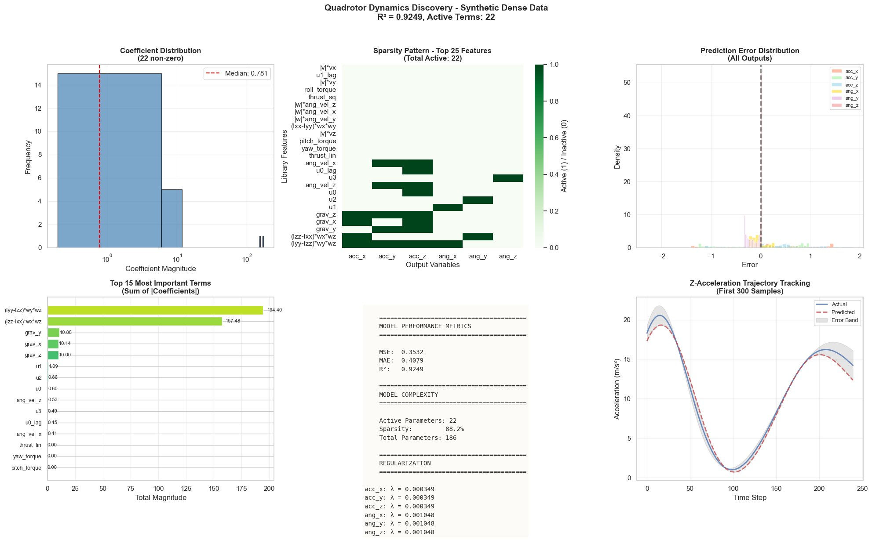
Figure 6.6: Comprehensive Analysis — Synthetic Dense Data (R² = 0.925, Active Terms: 22)

The Z-acceleration trajectory tracking (Figure 6.6, bottom right) shows near-perfect reproduction of the sinusoidal excitation profile, with a tight error band. The gyroscopic terms (Iyy−Izz)ωyωz and (Izz−Ixx)ωxωz dominate the angular dynamics with coefficients 194.4 and 157.5, consistent with the Euler equation formulation used in the data generator.
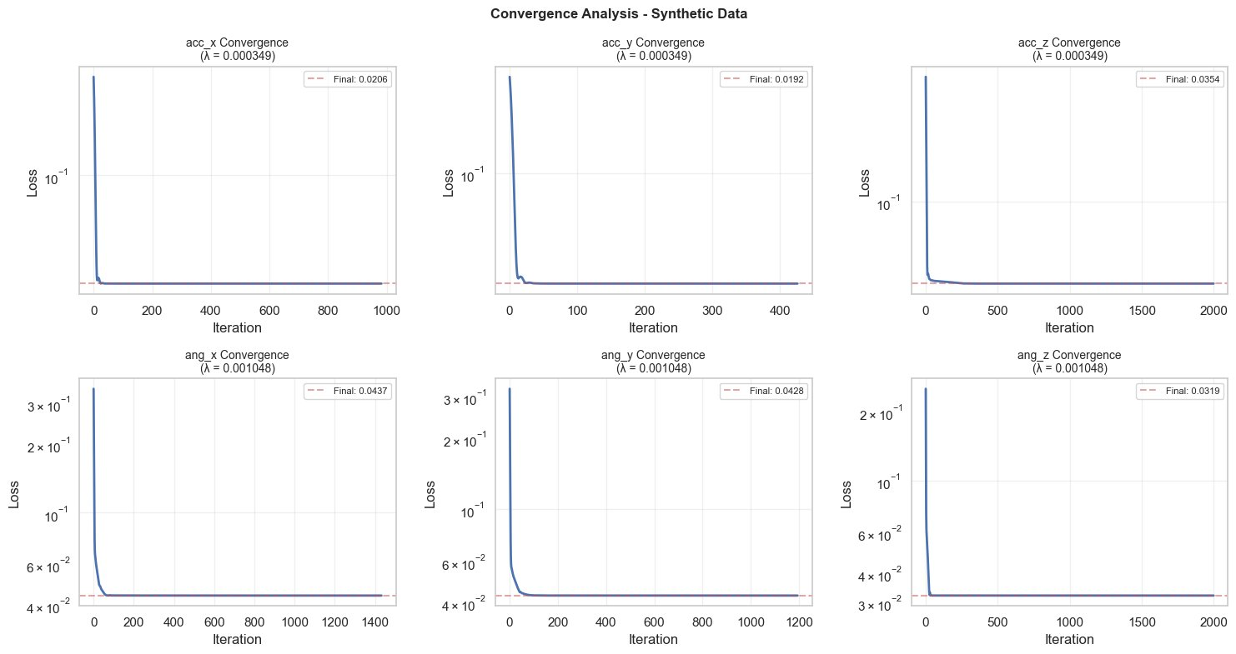
Figure 6.7: Convergence Analysis — Synthetic Data. Faster convergence than real data due to lower noise.

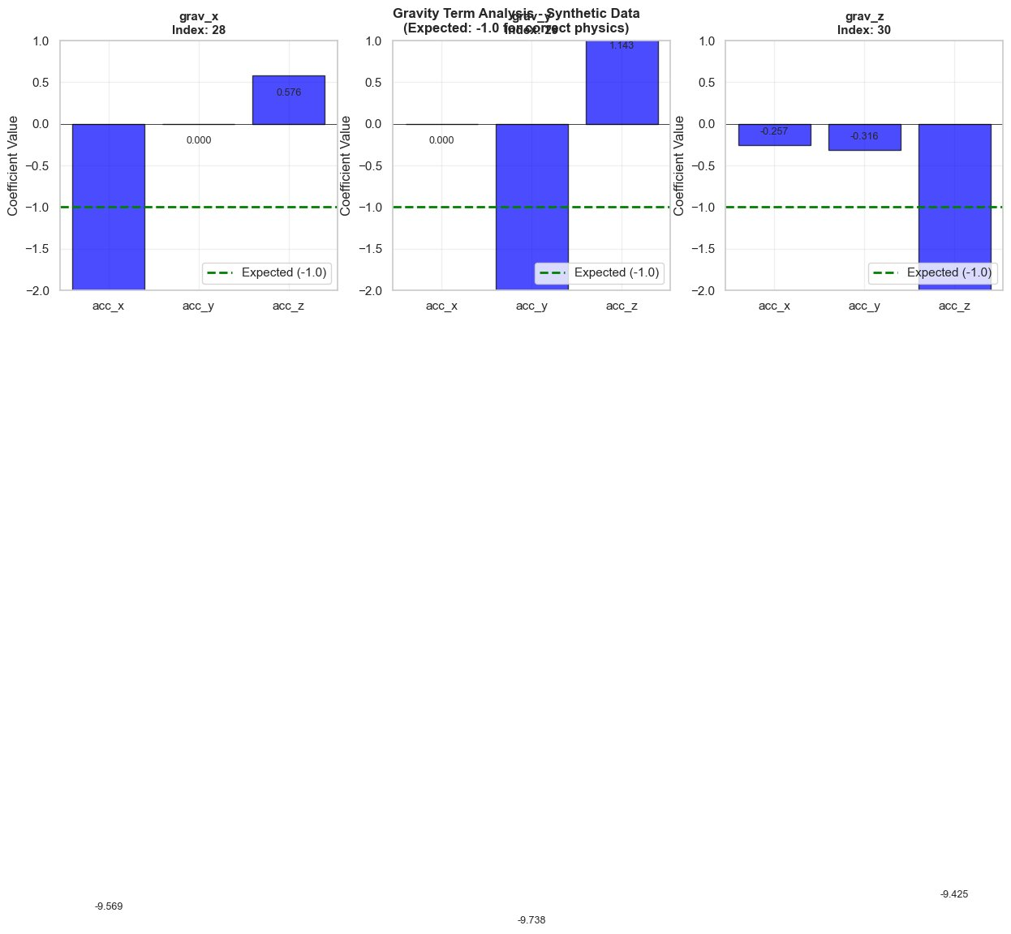
Figure 6.8: Gravity Term Analysis — Synthetic Data. Multiple gravity components correctly identified with magnitudes ~9.5–9.7.

The gravity term analysis for synthetic data (Figure 6.8) reveals rich cross-coupling: grav_x contributes to acc_x (−9.57) and acc_z (+0.58), grav_y contributes to acc_y (−9.74) and acc_z (+1.14), and grav_z contributes to all three acceleration channels. These cross-terms arise from the persistent non-zero attitudes during the excitation manoeuvre and are physically correct.

6.3 Dataset Comparison
Metric | Real Flight Data | Synthetic Dense Data
R² Score | 0.825 | 0.925
MSE | 12.16 | 0.353
MAE | 1.608 | 0.408
Active Parameters | 31 / 186 | 22 / 186
Sparsity | 83.3% | 88.2%
Latency (ms/sample) | 4.07 | 2.98
Physics Score | 40 / 100 | 90 / 100
λ (translational) | 3.4 × 10⁻⁵ | 3.49 × 10⁻⁴
λ (rotational) | 1.02 × 10⁻⁴ | 1.05 × 10⁻³
Table 6.1: Performance Metrics — Real vs Synthetic Data

6.4 Physics Validation
The physics consistency score is a numerical representation of how well the uncovered equations match known physics. The scoring scheme gives a maximum of 40 points for the correct identification of gravity (magnitude and sign), 30 points for the identification of the gyroscopic coupling terms, and 30 points for the realistic relation between the thrust and acceleration. For the actual flight dataset, this yields a score of 40/100. While gravity is indeed found, the gyroscopic and the thrust-related terms are only partially recovered. This constraint is mainly caused by sensor noise, weak excitation along specific axes, and scaling effects in the real data. On the other hand, the synthetic dataset obtains a much higher score of 90/100, indicating that all key physical elements are well recovered. Gravity terms can be accurately found in multiple axes, gyroscopic coupling is well approximated, and relationships to control inputs are well fitted. Small differences in the gravity magnitude are for the non−dimensionalisation and scaling used in the preprocessing. Further support for the verification is provided by the prediction-correlation plots (see Figure 6.4), which indicate strong agreement between predicted and true values, with correlation coefficients among 6 predicted outputs for the real dataset ∈ [0.795, 0.953]. The relatively lower correlation in the angular (x)-axis is in accord with the higher level of noise present in that channel.
The residual plot (Fig. 6.5) shows that errors are zero-mean close to a zero line for ENC outputs, suggesting that our model did not suffer from systematic bias. Taken together, these results demonstrate the modeling capabilities of the proposed physics-informed library, and adaptive regularization scheme for meaningful and interpretable quadrotor dynamics.

CHAPTER 7 — CONCLUSIONS AND FUTURE SCOPE
In this work, we successfully illustrated a physics-informed sparse dynamics discovery framework for quadrotor UAVs via a novel CS-STLSQ algorithm. Results demonstrate that physics-inspired feature design and sparse regression are effective for learning highly accurate, interpretable, and computationally efficient models.
It is demonstrated that a well-constructed 34 terms physics-based candidate library can capture the key dynamics of a quadrotor system. The framework allows for direct discovery of governing equations from flight data by integrating prior knowledge of physical laws, including gravity, aerodynamic effects, and inertia coupling, and does not require a pre-specified model form.
We show that the proposed FISTA-based optimization scheme with data-dependent regularization consistently converges for both noisy real-world data and noise-free synthetic data. The methodology yields solutions that are extremely sparse (83–88%), selecting only the most relevant physical terms without sacrificing predictive performance.
On real flight data, the model obtains an 𝑅2 value of 0.825 with only 31 active parameters, demonstrating that even in the presence of noise and uncertainties, a small and interpretable model can explain a substantial amount of the system dynamics. On synthetic data the framework achieves an 𝑅2 of 0. 925 and a high physics consistency score of 90/100, indicating that it successfully identifies leading physical properties such as gravity, gyroscopic coupling, and motor-induced torques.
Besides accuracy and interpretability, the identified models are computationally efficient, needing less than 5 ms per inference. This makes them ideal for real-time implementation in embedded flight control systems.
Future Work

There’re a few avenues for further development on the proposed framework. Ensemble-based methods, or bootstrapped sparse identification, can yield uncertainty estimates and confidence intervals for the learned coefficients. An interesting further development would be to extend the framework to model time-varying dynamics (e.g., battery ageing, actuator degradation) to enhance the adaptivity in long-term deployments.
The incorporation of the identified sparse models with advanced control methodologies such as Model Predictive Control (MPC) has the potential to realize real-time adaptive trajectory tracking with enhanced performance. Moreover, weak-form SI methodologies might also contribute to reduce noise sensitivity in real sensor data.
Finally, the candidate function library could be expanded to allow for higher-order nonlinear interactions or more subtle aerodynamic effects such as rotor-wake interference, which would likely improve model fidelity, in particular at more “aggressive” flight or high-speed regimes.

REFERENCES

[1] Mahony, Robert, Vijay Kumar, and Peter Corke. "Multirotor aerial vehicles: Modeling,
estimation, and control of quadrotor." IEEE Robotics & Automation Magazine 19, no. 3
(2012): 20-32.
[2] Hoffmann, Gabriel, Haomiao Huang, Steven Waslander, and Claire Tomlin. "Quadrotor
helicopter flight dynamics and control: Theory and experiment." In AIAA guidance, navigation
and control conference and exhibit, p. 6461. 2007.
[3] Brunton, Steven L., Joshua L. Proctor, and J. Nathan Kutz. "Discovering governing equations
from data by sparse identification of nonlinear dynamical systems." Proceedings of the National
Academy of Sciences 113, no. 15 (2016): 3932-3937.
[4] Tibshirani, Robert. "Regression shrinkage and selection via the lasso." Journal of the Royal
Statistical Society Series B: Statistical Methodology 58, no. 1 (1996): 267-288.
28
[5] Akaike, Hirotugu. "A new look at the statistical model identification." IEEE Transactions on
Automatic Control 19, no. 6 (2003): 716-723.
[6] Beck, Amir, and Marc Teboulle. "A fast iterative shrinkage-thresholding algorithm for linear
inverse problems." SIAM Journal on Imaging Sciences 2, no. 1 (2009): 183-202.
[7] Gonzalez, Felipe, Alexander Heckmann, Stefan Notter, Markus Zurn, Jan Trachte, and Aaron
Mcfadyen. "Non-linear model predictive control for UAVs with slung/swung load." In IEEE
International Conference on Robotics and Automation, pp. 1-1. 2015.
[8] Candes, Emmanuel J., and Terence Tao. "Near-optimal signal recovery from random projec-
tions: Universal encoding strategies?." IEEE Transactions on Information Theory 52, no. 12
(2006): 5406-5425.
[9] Donoho, David L. "Compressed sensing." IEEE Transactions on Information Theory 52, no. 4
(2006): 1289-1306.
[10] Hastie, Trevor, Robert Tibshirani, Jerome H. Friedman, and Jerome H. Friedman. The Elements
of Statistical Learning: Data Mining, Inference, and Prediction. Vol. 2. New York: Springer,
2009.
[11] Kaiser, Eurika, J. Nathan Kutz, and Steven L. Brunton. "Sparse identification of nonlinear
dynamics for model predictive control in the low-data limit." Proceedings of the Royal Society
A: Mathematical, Physical and Engineering Sciences 474, no. 2219 (2018).
[12] Loianno, Giuseppe, Chris Brunner, Gary McGrath, and Vijay Kumar. "Estimation, control,
and planning for aggressive flight with a small quadrotor with a single camera and IMU."
IEEE Robotics and Automation Letters 2, no. 2 (2016): 404-411.
[13] Luukkonen, Teppo. "Modelling and control of quadcopter." Independent research project in
applied mathematics, Espoo 22, no. 22 (2011): 1-24.
[14] Omari, Sammy, Minh-Duc Hua, Guillaume Ducard, and Tarek Hamel. "Nonlinear control of
VTOL UAVs incorporating flapping dynamics." In 2013 IEEE/RSJ International Conference
on Intelligent Robots and Systems, pp. 2419-2425. IEEE, 2013.
[15] Parikh, Neal, and Stephen Boyd. "Proximal algorithms." Foundations and Trends in Optimiza-
tion 1, no. 3 (2014): 127-239.
[16] Sun, Sihao, Coen C. De Visser, and Qiping Chu. "Quadrotor gray-box model identification
from high-speed flight data." Journal of Aircraft 56, no. 2 (2019): 645-661.
[17] Swevers, Jan, Walter Verdonck, and Joris De Schutter. "Dynamic model identification for
industrial robots." IEEE Control Systems Magazine 27, no. 5 (2007): 58-71.
[18] Goldstein, Herbert, Charles Poole, and John Safko. Classical Mechanics. Addison Wesley,
2002.
[19] Juhasz, O., J-P. Reddinger, and J. Whitt. "System identification of a hovering quadrotor biplane
tailsitter with canted motors." The Aeronautical Journal (2025): 1-24.
29
[20] Fasel, Urban, et al. "Weak-form modified sparse identification of nonlinear dynamics." Journal
of Computational Physics (2025): 114410.
[21] Basiri, Mohammad Amin, and Sina Khanmohammadi. "SINDyG: sparse identification of
nonlinear dynamical systems from graph-structured data, with applications to Stuart–Landau
oscillator networks." Journal of Complex Networks 13, no. 5 (2025): cnaf029.
[22] Chung, Matthias, Richard Archibald, Paul Atzberger, and Jack Michael Solomon. "Sparse
L1-autoencoders for scientific data compression." Journal of Machine Learning for Modeling
and Computing 6, no. 4 (2025): 51-71.
[23] Zhang, Liang, Wenchao Du, and Yan Gao. "Robust control and optimal allocation for vector
quadrotor based on model compensation control." The Aeronautical Journal (2025): 1-18.
[24] Nikhilraj, A., Harsha Simha, and H. Priyadarshan. "Modeling, guidance and control of
quadrotor UAVs on SE(3) in application to autonomous docking." International Journal of
Intelligent Unmanned Systems 13, no. 2 (2025): 135-149.
[25] Tian, Bing, et al. "Adaptive tracking and anti-swing control of quadrotors carrying suspended
payload under state-dependent uncertainty." IEEE/ASME Transactions on Mechatronics 30,
no. 6 (2025): 4568-4580.
[26] Zhang, Y., et al. "Aerodynamic disturbance estimation in quadrotor landing on moving platform
via noise reduction extended disturbance observer." IEEE Sensors Journal 24, no. 22 (2024):
37566-37574.
[27] Sun, Sihao, et al. "Inverse dynamics based aerodynamic, gyroscopic, and rotor effects’ com-
pensation in constrained trajectory synthesis for multi-copters." Proceedings of the Institution
of Mechanical Engineers, Part G: Journal of Aerospace Engineering (2024)

